1. **Write at least 5 test cases which will verify any l18n aspect**

**The “App”** is the conditional name of the application only for writing some examples of test cases

**ID -** TC01

**Priority -** High

**Title -** Ensure that “App” supports French and German languages

**Pre-condition** - default language is English

**Steps**

* Go to “App”
* Switch language to French
* Verify if the translation changed
* Switch language to German
* Verify if the translation changed

**Expected result -** The “App” supports and works correctly when switching languages to German and French

**ID -** TC02

**Priority -** High

**Title -** Ensure that “App” supports different timezones

**Pre-condition -** default timezone is GMT+3

**Steps**

* Go to “App”
* Switch timezone to GMT+6
* Verify if the time displays according to timezone
* Switch timezone to GMT+8
* Verify if the time shows according to timezone

**Expected result -** The “App” supports and works correctly when switching timezones to GMT+6 and GMT+8

**ID -** TC03

**Priority -** High

**Title -** Ensure that “App” supports different currency formats according to country

**Pre-condition -** default country is Germany

**Steps**

* Go to “App”
* Check if the currency is in EUR
* Switch country to the USA
* Check if the currency is in USD

**Expected result -** when changing countries - the currency formats changes according to country

**ID** - TC04

**Priority** - High

**Title** - Ensure that “App” supports text conversions according to the Arabic language

**Pre-condition** - default language is English

**Steps**

* Go to “App”
* Switch language to Arabic
* Verify the text displays correctly

**Expected result** - when changing the language from English to Arabic - the text displays correctly according to the Arabic language

**ID** - TC05

**Priority** - High

**Title** - Ensure that the “App” supports different date formatting when changing countries

**Pre-condition** - default country is the UK

**Steps**

* Go to “App”
* Check the correct date format
* Switch country to the USA
* Check the correct date format

**Expected result** - when changing country from the UK to the USA - the date format displays correctly

1. **Write at least 5 test cases which will verify any L10n aspect**

**The “App”** is the conditional name of application only for writing some example of test cases

**ID** - TC01

**Priority** - High

**Title** - Telephone number has “+32 2 XXX XX XX” format when change country to “Belgium”

**Steps**

* Go to “App”
* Change country to “Belgium”
* Check that the phone number displays according to “+32 2 XXX XX XX” format

**Expected result** - When changing country to “Belgium” - the phone number format changes to “+32 2 XXX XX XX”

**ID** - TC02

**Priority** - High

**Title** - Verify that all buttons on the main menu in English after switching language into English

**Steps**

* Go to “App”
* Switch language to English
* Pay attention to the main menu buttons

**Expected result** - all main menu buttons in English language after switching the language to English

**ID** - TC03

**Priority** - High

**Title** - Verify that date format changes from DD/MM/YYYY to MM/DD/YYYY after changing country from Germany to the USA

**Steps**

* Go to “App”
* Change country to the USA
* Pay attention to the date format

Expected result - date format changes from DD/MM/YYYY to MM/DD/YYYY after changing country from Germany to the USA

**ID** - TC04

**Priority** - High

**Title** - Verify that time format changes from 24h to 12h format when changing country to the USA

**Pre-condition** - default country is Germany

**Steps**

* Go to “App”
* Change country to the USA
* Pay attention to the time format

**Expected result** - time format changes from 24h to 12h type when change country to the USA

**ID** - TC05

**Priority** - High

**Title** - Verify that advertisement displays in German when Germany was chosen in the country list

**Steps**

* Go to “App”
* Change country to Germany
* Pay attention to the advertisement

**Expected result** - Advertisement displays in German when Germany was chosen in the country list

1. **Find at least one l18n and at least one L10n defect and create two bug reports**

Bug reports:

**ID - 01**

Title - After changing language to Greece “Continue” button is not translated correctly

Environment - Google Chrome, Version 102.0.5005.61

Severity - Low

Priority

Steps to reproduce

* Go to “Lufthansa.com”
* Scroll down to country/language list
* Change country to Greece
* Change language to Greece
* Scroll up to the Flight manager menu
* Pay attention to the “Continue” button

Actual result - when changing language to Greece “Continue” button is not translated correctly

Expected result - When changing language to Greece - the “Continue” button has to be translated to Greece language

Attachment -

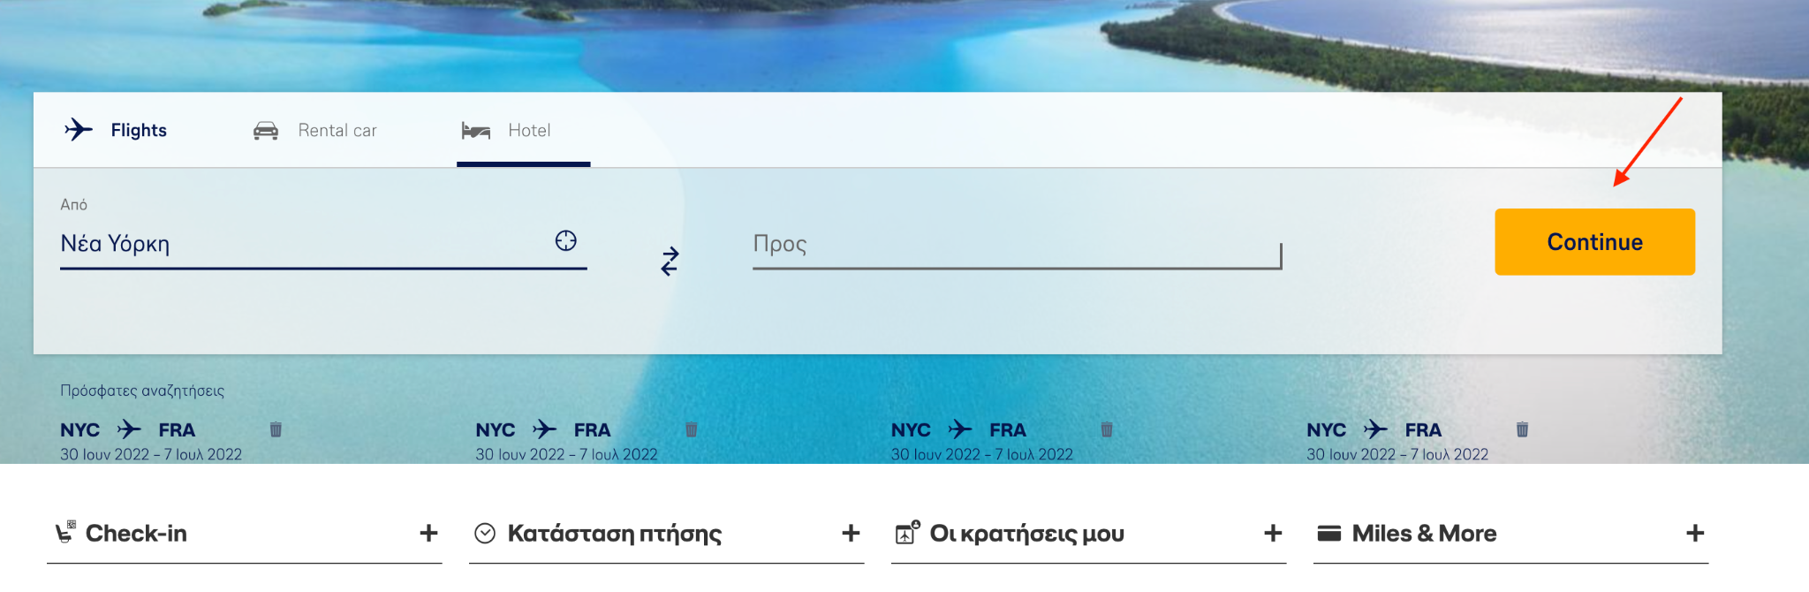

**ID - 02**

Title - When choosing Ukraine country - there is no Ukrainian language on the language list

Severity - High

Priority

Environment - Google Chrome, Version 102.0.5005.61

Steps to reproduce

* Go to “Lufthansa.com”
* Scroll down to the country/language list
* Choose Ukraine in the country list
* Pay attention to the language list

Actual result - there is no Ukrainian language in the language list when choosing Ukraine

Expected result - it is expected that when Ukraine is chosen in the country list it has to be Ukrainian language in the language list

Attachment - 